**Devops day3 notes**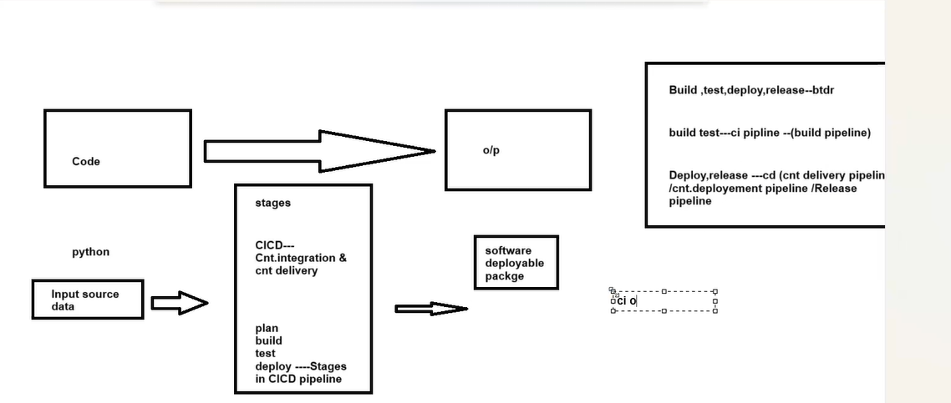

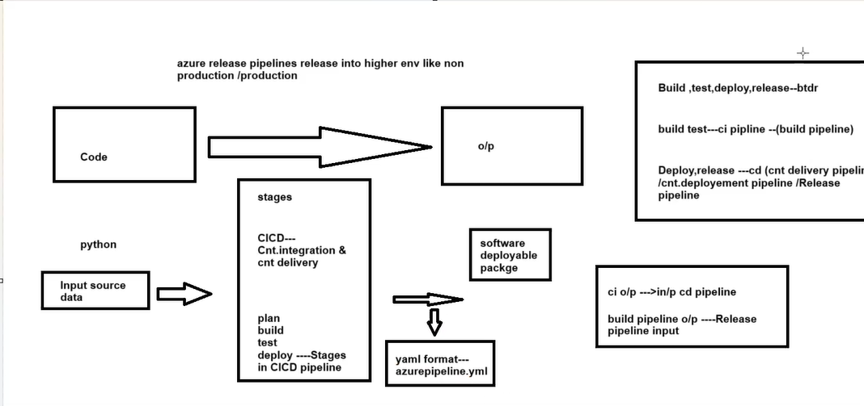

Stages in CICD pipeline–---------------🡪{BTDR}

* **Build-🡪CI**
* **Test-🡪CI**
* **Deploy-🡪CD**
* **Release-🡪CD**

Artefact--🡪output of build/test

In databricks--🡪Cluster environment

In devops------🡪Deployment environment

Azure pipeline environment : -🡪where you deploy artifacts

* records the deployment history to help identify the source of changes
* also define security checks and ways to control how artifact is promoted from one stage of pipeline to another

One way to define azure pipeline environment is with YAML file. That file contains environment section.

Deployment environments

* Virtual machines
* Containers
* Azure app services
* Serverless
* Computing